MAHARAJA INSTITUTE OF TECHNOLOGY MYSORE
Belawadi, SrirangapatnaTq, Mandya-571477
DEPARTMENT OF CSE (Artificial Intelligence)

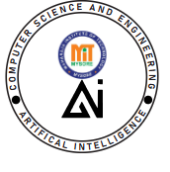
Assignment – Project Report
2025-26

Subject Name:

Subject Code:

Semester:

Submitted by: Team No:
Sl. No. | Student Name | USN. |  | CO’s Mapping |  |  |  | Total | Scaled to
Sl. No. | Student Name | USN. | CO1 | CO2 | CO3 | CO4 | CO5 | Total
1 |  | 4MH
2 |  | 4MH
3 |  | 4MH
4 |  | 4MH

Verified and Approved by:
Faculty Name:
Signature:
Date:

Project GitHub Repository:
Link: ___________________________________________
QR Code

